EMCH361 Mechanical Engineering Laboratory I, Fall 2022

Laboratory 1

DETERMINING HARDNESS OF Metal-Alloy AND Carbon-based SAMPLES

Vaught, Jacob
Section 006
Email: jvaught@sc.edu
Date: 9/30/2022
Department of Mechanical Engineering
University of South Carolina
Columbia, SC 29208

Abstract

This experiment was initiated to ascertain the hardness of an alloy-based sample and a synthetic carbon-based sample using the provided lab equipment. The measured results were also used in statistical analysis to ascertain the hardness value with a confidence of 80%. The equipment used was a Vickers Microhardness tester which is able to employ a maximum load of 1 kgf to the sample to create an indent. A Shore Type A durometer was used to determine the hardness of the synthetic carbon-based sample. The alloy-based sample was calculated to have a hardness value of 280.33 ± 1.72 𝐻𝑉 while the rubber sample was calculated to have a hardness value of 35.26 ± 0.256 𝐻𝑉 both of which having an 80% confidence interval. The results are accurate and are to be believed as the standard deviation is low. The materials for the samples were determined to be a steel alloy and a rubber with a HV of 35.

introduction

The hardness of a substance is one of the most important characteristics of materials, especially to engineers when designing machinery and parts. Hardness is the ability of a material to resist indentation, scratching, or penetration [1]. The hardness is used to determine some parameters of materials without having to resort to a catastrophic tensile strength test [2]. This strength is the amount of stress that the material can take before finally it fails and either permanently deforms or even breaks entirely [2]. The hardness can be determined from an indentation test [2]. Hardness is not a calculatable property and thus must be measured. This is due to the hardness not being a characteristic but rather a property which is easily affected by outside forces in many ways.
The lab wants to determine the hardness value of 2 separate objects which are made of different materials. Materials that undergo plastic deformation, rather than elastic deformation are indented to determine hardness, however if the material is extremely hard, then the material is not indented but is instead scratched [1]. Indentation size can be measured to determine the material hardness. The depth and width of the indentation and the force applied by the tester are considered to determine the hardness as shown in Eq 1 [3]. There are many types of hardness testers, however, the Vickers micro tester was used. There is also the Knoop, Brinell, and Rockwell type testers. The Vickers was used due to the small sample size, as well as the small load limit of the machine which can be seen in Figure 1.

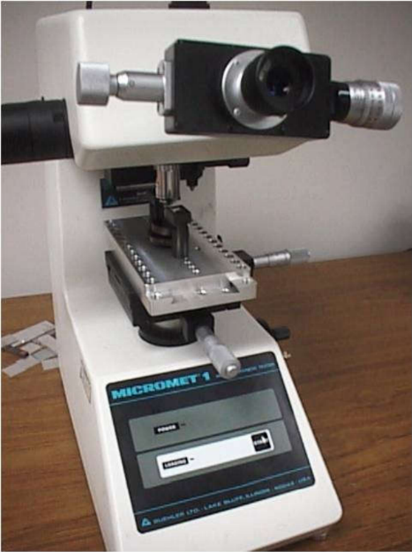
Figure 1 shows the testing machine used in the test
The Micro-Vickers is only rated for loads up to 1 kgf and the indenter shape is that of a pyramid diamond with a square base and that has angle between two faces is equal to 136 degrees; refer to Figure 2 for an illustration.

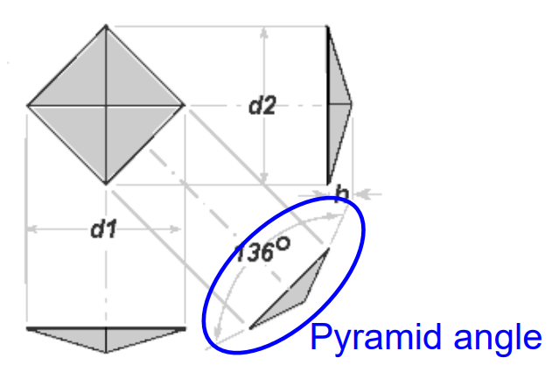
Figure 2 shows an example of an indentation and the relationship between angle and angle [1]

The length of the two diagonals created from the square based pyramid are measured and the mean is then calculated with the following equation (1).
$d=\frac{d_{1}+d_{2}}{2}$ (1)
Where d₁ (µm) is the length of the first diagonal while d₂ (µm) is the length of the second diagonal. These two are then averaged to get a d value which is used in the Vickers hardness formula equation (2).
$HK=1.854*{10}^{6}*\frac{F}{d^{2}}$ (2)
The HK in equation (2) is the hardness value that is retrieved during the Micro-Vickers hardness test. 1.854x10⁶ is a constant used for only the Vickers methodology. The force in the above equation is the force that the testing machine exerts.
Micro-testers have a big disadvantage due to the surface of the sample being clean and level. An unlevel surface can cause issues with having a clear indentation in the sample with undefined lines to measure the d₁ and d₂ values. This would result in an inaccurate value and would make the Vickers hardness value incorrect.
The second part of this experiment was determining the hardness of a rubber sample. This sample required a durometer due to its high elasticity value. A durometer had to be used, as they are usually used for polymers, rubbers, plastics, and other gel-like materials [1]. As with the other indenting testers, the durometer has many types to pick from. In the experiment a Shore Type A was used since it can be used to read hardness of more pliable materials. This group chose the red rubber sample from the lab samples available. See Figure 3 for an example of the Shore A durometer used in this experiment.

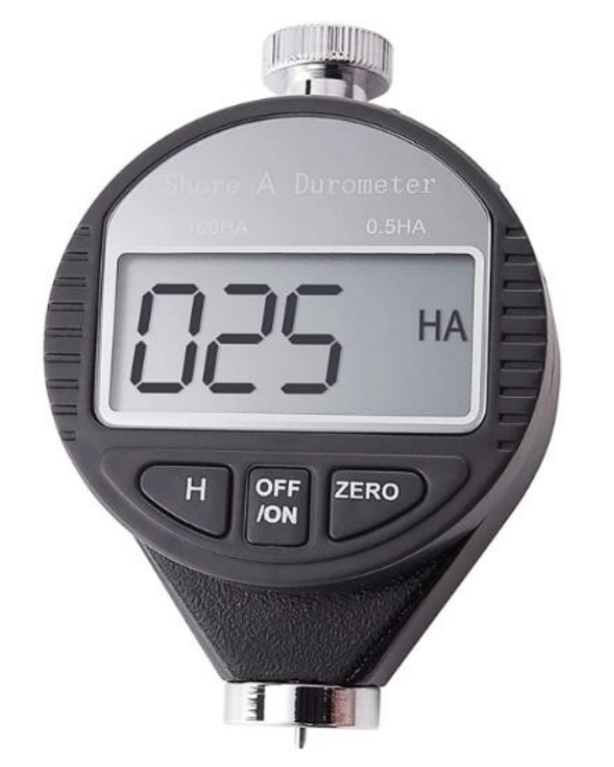
Figure 3 shows a Shore A Type Durometer similar to the model used in the experiment.

Instruments
During this lab two pieces of equipment were used. The two pieces of equipment used were the Micro-Vickers Hardness Tester and the Shore A Durometer. An example of both can be seen in Figure 1 and Figure 3 respectfully. The Vickers tester was used for the metallic sample. The durometer was used for the rubber sample.

Lab Procedure
The TA completed a large portion of the set up for the students. The TA prepped the metal surface and secured it to the self-leveling platform on the Micro-Vickers hardness tester. The TA split the class into 2 groups, in which one group would complete the testing of the rubber sample, and the other group would complete the metal testing due to time constraints. After each group completed a section, they switched to the other machines and completed another testing. The groups selected one person to create an indentation in the metal surface. This involved finding a location on the metal surface that was free of any other previous indents and free of debris. The tester head was then rotated to the indenting head and the Vickers machine created an indentation after a pressing a button. See Figure 4 for a detailed view of the Vickers adjustments and settings.
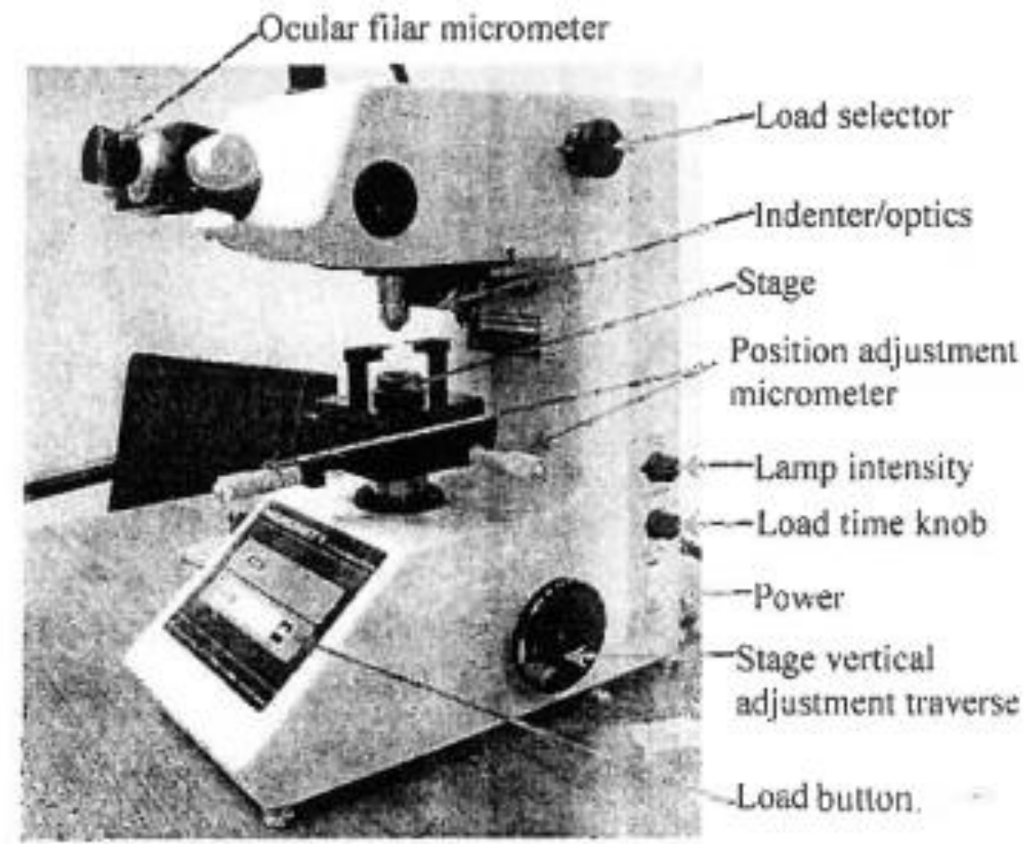
Figure 4 shows a detailed breakdown of the controls on the Vickers Hardness Tester
After the indentation was created, the head was switched to the high-power microscope. This allowed the measurement of the tiny indentation to be easier. The indentation was set in the center of the viewport, then measured. See Figure 5 below for an example.

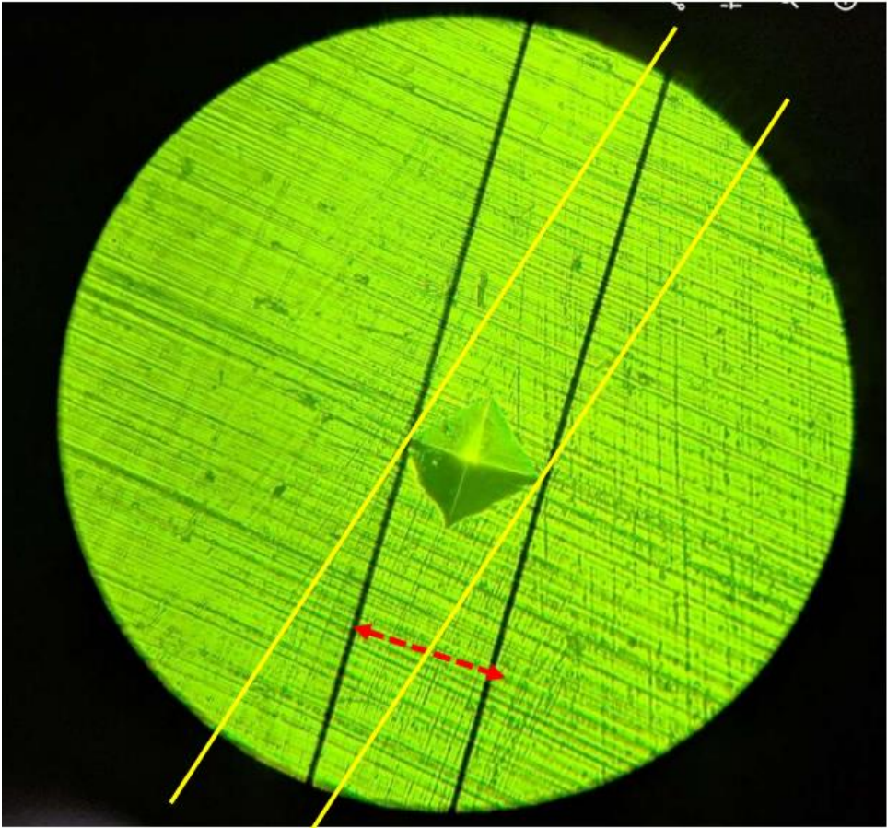
Figure 5 shows the view through the Vickers hardness tester to measure the indentation

Black lines are made into the scope, yellow is how not to measure the diagonals [1]. The left bar is fixed, thus it had to be adjusted to the left corner, or top corner depending on which rotation the student had the scope in. d₁ was the horizontal diagonal and the vertical diagonal was d₂. Only one indentation was made, and thus, all 5 students made a measurement of the same indent 5 times. This is where the data values came from and once the student had collected their data another one took their place. Once all the students finished with the metal sample the experiment proceeded to the second part of the experiment.
For the second part, the students were given a choice of rubber samples from a box of samples to pick. The samples had premeasured values of hardness and this data would be compared to the known value. This lab section chose the pink sample which was rated to 36 HA. The durometer was then zeroed, and measurements were taken. The durometer must be perpendicular to the sample otherwise the hardness value would not read correctly due to how the durometer is made. The 5 students took 5 data points with the durometer, making certain to not test the same area of the sample. Once that was completed the students compared data to make sure they all received the same data due to having to share the data. Once completed, the long and tedious journey for the data analysis could begin.
The variables in the experiment are as follows. The independent variable is the load used to create the indentation. The dependent variable is the width and depth of this indentation due to the variation of the materials being used. In the durometer the indentation location is the dependent variable.

Results and Discussions
Metal Hardness
Indent # | d1 | d2 | D | HV
1 | 81.5 | 82.5 | 82 | 275.7287329
2 | 81.5 | 82 | 81.75 | 277.4177258
3 | 80.5 | 79.5 | 80 | 289.6875
4 | 82.5 | 80.5 | 81.5 | 279.1222854
5 | 82 | 82 | 82 | 275.7287329
6 | 83.5 | 81 | 82.25 | 274.0551177
7 | 82.5 | 81.5 | 82 | 275.7287329
8 | 82.75 | 82.5 | 82.625 | 271.5731219
9 | 82.75 | 82 | 82.375 | 273.2240186
10 | 81 | 81.5 | 81.25 | 280.8426036
11 | 81.5 | 82.5 | 82 | 275.7287329
12 | 82 | 82.5 | 82.25 | 274.0551177
13 | 81 | 82.5 | 81.75 | 277.4177258
14 | 82.5 | 82.5 | 82.5 | 272.3966942
15 | 80.5 | 81.5 | 81 | 282.5788752
16 | 81.5 | 81.5 | 81.5 | 279.1222854
17 | 82.5 | 80.5 | 81.5 | 279.1222854
18 | 80.5 | 81.5 | 81 | 282.5788752
19 | 82.5 | 80.5 | 81.5 | 279.1222854
20 | 80 | 81 | 80.5 | 286.1000733
21 | 80.5 | 81 | 80.75 | 284.3312981
22 | 80 | 81 | 80.5 | 286.1000733
23 | 78 | 79.5 | 78.75 | 298.9569161
24 | 79 | 80 | 79.5 | 293.3428266
25 | 81 | 80.5 | 80.75 | 284.3312981
Table 1 shows the tabulated data from the metal hardness lab [5]

Rubber Hardness
Indent # | HV | Indent # | HV
1 | 34.5 | 14 | 36
2 | 34 | 15 | 35.5
3 | 34.5 | 16 | 34.5
4 | 35 | 17 | 36
5 | 34 | 18 | 33
6 | 36.5 | 19 | 34
7 | 37 | 20 | 34.5
8 | 36 | 21 | 35.5
9 | 35.5 | 22 | 35
10 | 36 | 23 | 34.5
11 | 35.5 | 24 | 35
12 | 36.5 | 25 | 37
13 | 36 | Average: | 35.26
Table 2 shows the tabulated data from the rubber sample.[5]

The average length for the diagonal on the metal test was 81.34 µm. As Figure 6 and Table 1 show, the data was relatively accurate with a standard deviation of only 0.9605, as calculated by Microsoft Excel. The average hardness for the metal sample was calculated to be 280.33 on the Vickers scale.

Figure 4 shows the scatterplot of average d values from [5]

The standard deviation of the steel hardness level was 6.736 which means the measurements were relatively precise and accurate. This was calculated via the Built-In Excel function. The rubber sample had a standard deviation of 1.02 which was rather good. The sample may have had so much variation due to human error or machine error

Figure 5 depicts the histogram of HV values from the metal tests [5]

The average hardness of the metal alloy, in addition to other characteristics, such as density and color point to the metal most likely being a type of Steel alloy. A reference table of possible materials has been tabulated and compiled in Table 5. The table was compiled after using reference data in Table 5, Page 496 and Table 3, Pages 379-381 from reference [6]. Converting the value of Vickers into Rockwell C-Scale was trivial and was approximately 27 Rc.

Figure 6 depicts the scatter plot of the rubber material data collected

The rubber sample was tested, and its actual hardness value was known at 36 HA. The average hardness that was calculated via excel was 35.26 HA. The error was most likely due to the varying amounts of pressure each person put in the durometer, which greatly affected results.

Confidence Level | 0.8
Significance Level | 0.2
Mean | 280.3
St Dev | 6.7
Sample Size | 25.0
Confidence Value | 1.7
Confidence Interval | 280.33 +/- 1.72
Table 3 shows the excel sheet used to calculate the confidence interval for the metal sample

Confidence Level | 0.800
Significance Level | 0.200
Mean | 35.260
St Dev | 1.001
Sample Size | 25.000
Confidence Value | 0.257
Confidence Interval | 35.26 +/- 0.256
Table 4 shows the excel sheet used to calculate the confidence interval for the rubber sample

The mean hardness value as well as the standard deviation combined with the 80% confidence interval given by the lab TA allows excel to calculate the needed values. Via a built-in excel function, the confidence value of the metal can be calculated, and the confidence interval results in 280.33 ± 1.72 𝐻𝑉 as seen in Table 3. The rubber sample has an interval of 35.26 ± 0.256 𝐻𝑉 as seen in Table 4.
Recommendations include updating the handout for the lab, having a “pre-lab” lab the week prior to go over lab equipment, including resources for estimating the metal alloy types, and having a ‘.docx’ template instead of a PDF.

CONCLUSIONS

In this lab the hardness of metal and rubber samples were determined. These samples required different methods for obtaining hardness values. The metal sample required use of a Micro-Vickers tester which created an indentation on the metal when a 1 kgf force was applied. The rubber sample was tested via a durometer. The standard deviation and confidence interval for both the metal and rubber samples were determined. The goal of determining the sample material based on the hardness went well and the wealth of knowledge in Reference [6] was invaluable to this monumental task. The Vickers machine worked well other than human error. The recommendations are simple, have a “pre-lab” lab the week prior to go over lab equipment, include resources for estimating the metal alloy types, and provide a ‘.docx’ template instead of a PDF for reports. Even with these issues, the lab produced accurate results for both samples.

ACKNOWLEDGMENTS

The author would like to thank Dr. Xingjian Xue and Deb Mandal for their help in setting up and the aid provided during the experiment during the lab time. The University of South Carolina must also be thanked for providing the funding to the engineering college to fund these extremely useful lab experiences, and one can only hope that they will improve in the future.

Material Name | Hardness (Rc) Rockwell C-Scale
Copper-Base Alloys
Hardened Beryllium Cu 275C (828) | 25-44
Carbon and Low-Alloy Steels and Iron
IC 1030 Hardened | 20-50
IC 1035 Hardened | 25-52
IC 1045 Hardened | 25-57
IC 4130 Hardened | 23-49
IC 4150 Hardened | 25-58
IC 4330 Hardened | 25-48
IC 4340 Hardened | 20-55
IC 4620 Hardened | 20-32
IC 8620 Hardened | 20-45
IC 8630 Hardened | 25-50
IC 1722AS Hardened | 25-48
Hardenable Stainless Steel
IC 431 Hardened | 20-40
IC 15-5 Hardened | 26-38
CD-4M Cu Hardened | 28-32
Nickel-Base Alloy
S Monel Annealed | 20-28
RH Monel | 20-30
Cobalt Base Alloy
Cobalt 21 As Cast | 24-32
Cobalt 31 As Cast | 20-30
F75 As Cast | 25-34
Tungsten Base (Compressed and Sintered Powdered Metal Alloys)
95W, 3.5Ni, 1.5Cu | 27
95W, 3.5Ni, 1.5Fe | 27
97W, 2.1Ni, 0.9Fe | 28
Table 5 shows the tabulated results of all possible metals the alloy tested could match.

REFERENCES
[1] Xue, X., “Lecture #7 Fall 2022” Hardness Testing Background. Accessed September 30, 2022.
[2] Xue, X., “In Person Lecture Discussion” Hardness and Associated Properties. Accessed September 30, 2022.
[3] WonVon, “Portable Shore A Durometer” Accessed September 30, 2022, https://www.amazon.com/Portable-0-%20100HD-Hardness-Durometer%20Flooring/dp/B07Z1RP3CD/
[4] Xue, X., “Hardness Lab Handout” Hardness Tests. Accessed September 30, 2022.
[5] Vaught, Jacob, Lab Experiment Results. Accessed September 30, 2022.
[6] Oberg, E. (2016), Machinery’s Handbook, 30th Edition. South Norwalk, Connecticut, ISBN-13: 9780831130916

